Digital Transformation Enabler <DXE Featured Technology Name>

An Industry IoT Consortium Whitepaper

2023-03-21

Authors

*Your Name (Organization), Claude Baudoin (*cébé *IT & Knowledge Management), Erin Bournival (Dell Technologies), Chuck Byers (Industry IoT Consortium), Abhijeet Kelkar (GEOOWN), Howard Kradjel (Industry IoT Consortium), Alfred Strauch (SmartTalk Security), Daniel Young (Toshiba America), and Bassam Zarkout (IGnPower).*

Contents

1. About Digital Transformation Enablers 4

1.1 Digital Transformation 4

1.2 Digital Transformation Enablers 5

1.3 How to use a DXE Playbook 6

2. DX Enabler – [TECHNOLOGY] 7

2.1 [TECHNOLOGY] Background 7

2.2 Contacts 7

2.3 Stakeholders 7

2.4 Strategy/Vision for Applying the DXE to Achieve Business Transformation 7

2.5 Policies for Applying The DXE To Achieve Business Transformation 7

2.6 Standards 7

2.7 Supporting Enabling Technologies 7

2.8 Headwinds and Tailwinds 8

2.9 Architecture Frameworks and Models 8

2.10 Education/Skills 8

3. Digital Transformation Examples 9

4. Applicability to Other verticals and Use Cases 10

5. Appendix 11

5.1 DXE Reference Model 11

6. Authors & Legal Notice 12

Figures

Figure 5‑1: Visual representation of a Digital Transformation Enabler playbook. 10

Tables

Table 2‑1: Technologies that work in conjunction with this DXE to effect transformation. 6

# About Digital Transformation Enablers

## Digital Transformation

Organizations in industry are under pressure from a relentless barrage of emerging and emergent digital technologies that threaten to disrupt and transform their business and operations. Organizations that fail to act on these threats (and opportunities) risk significant disruptions to their business and operations, exposing them to pressures from nimbler and more innovative competitors threatening to make them obsolete.

*Digital transformation* (DX) is a catch-all term that refers to efforts by organizations to leverage disruptive technologies and transform the way they operate and deliver value to the market. The overall objective of DX is to deliver better outcomes to customers and shareholders and achieve better ROI, while maintaining compliance, security and trustworthiness throughout the transformation journey.

Figure 1-1: Digital transformation journey. Source: IIC.

The term *industry digital transformation* (IDX) reflects the digital transformation context within industry. IDX is primarily a business endeavor focused on the coherent and innovative application of emerging and emergent digital technologies in a principled manner, and the strategic realignment of the organization towards the improvement of business models, industrial models, and processes and ultimately the creation of entirely new ones.

One important aspect of IDX initiatives is that they involve sensor-driven IoT solutions that by definition incorporate a digital/physical boundary. This results in concerns about the IT/OT[1] divide and a potential convergence and integration between their respective operations. These concerns manifest themselves during the transformation journey and at multiple levels, including systems, procedures, best practices, compliance, organization structure and workforce.

Another perspective on digital transformation is that it covers three related areas: *digitization*, *digitalization* and *digital transformation*. *Digitization* deals with the conversion of analog operational data into digital form to facilitate the use of this data within operational processes. *Digitalization* deals with the ingestion and consumption of the digitized data into operational processes for the purpose of optimizing and integrating them. *Digital transformation* builds on the above and leverages disruptive technologies to create new and innovative business and operational and service delivery models and uncover new revenue opportunities and compete in new markets.

For further information about digital transformation, please refer to the “Digital Transformation in Industry paper”[2] and “Digital Transformation Journey in the Enterprise and its Leadership” Journal of Innovation article,[3] both published by the Industry IoT Consortium (IIC).

## Digital Transformation Enablers

*Digital transformation enablers* (DXEs) are specific digital technologies that can enable or accelerate the transformative effects of core processes, the enterprise and its operations.

A DXE playbook provides a description of a DXE (focused on a particular technology) and includes examples of the use of this technology in real-world applications, the issues that had to be considered and the concerns that had to be dealt with, and how. The document can also help a stakeholder understand ways in which this technology can transform a core process and ultimately a business, ranging from strategies and policies to frameworks, standards and technologies. DX efforts are driven by business initiatives that are often motivated by pain points, such as difficulties in uploading software to automobiles or the high costs associated with unscheduled maintenance.

Some DXEs apply to a specific set of application verticals, although many can be employed more widely. However, since adopters can generally understand examples pertaining to their own industry better than examples in other industries, DXE playbooks will include multiple examples to foster deeper understanding. The DXE playbook supplements associated frameworks by providing guide points rather than a map of the technical and architectural capabilities and considerations related to the technology.

### Relationship With IIC’s IIRA and Existing Technology Frameworks

Each DXE playbook is aligned with the viewpoints of the IIoT as defined in the IIC Industrial Internet Reference Architecture (IIRA[4]). It is also aligned with the specific technology frameworks that are regularly published by the IIC–for example, the Industrial Analytics Framework[5], the Industrial IoT Artificial Intelligence Framework[6] and Industrial Internet Security Framework.[7]

## How to use a DXE Playbook

The following diagram highlights the steps involved in using a digital transformation enabler:

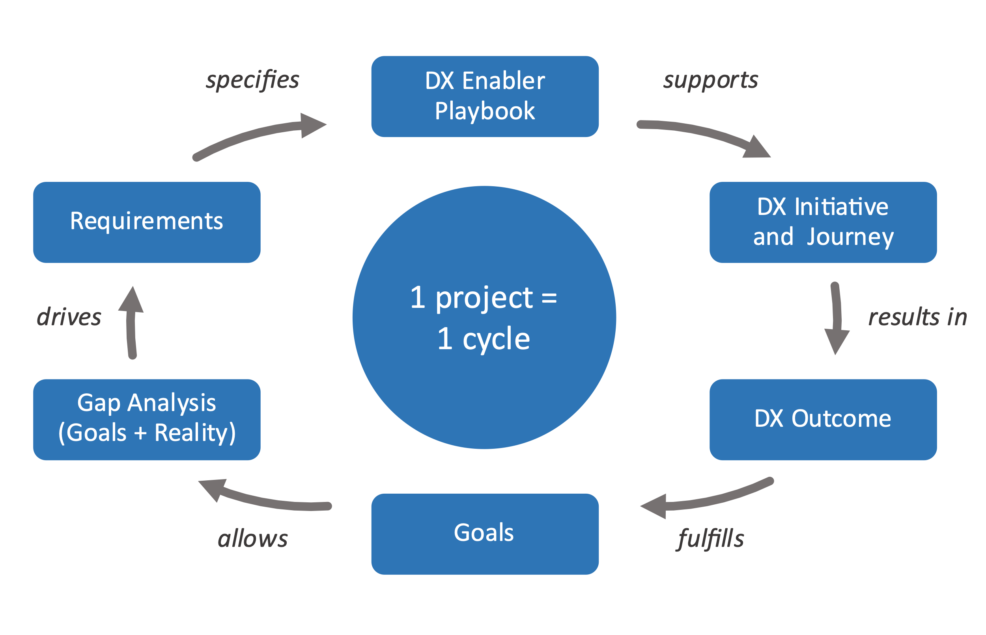

Figure 1-2: Steps involved in using the DX Enabler. Source: IIC.

These steps are typically executed in the following order:

* The reader reads the DXE playbook.
* With the knowledge gained, the reader’s organization begins ML-specific tasks (design, implementation, operation) that support the DX journey.
* This transformation enables the organization to achieve a transformative outcome.
* The organization is now equipped to fulfill new goals in a way that were not possible before the transformation.
* The reader can now perform a gap analysis to see in which ways the organization can be improved.
* This analysis drives the creation of new requirements.
* New requirements may call for the deployment of a new technology that has not yet been previously considered.
* The reader obtains another DXE playbook focused on this new technology and restarts the process again at the first step.

# DX Enabler – [TECHNOLOGY]

## [TECHNOLOGY] Background

[Describe what is the technology is, and how it enables transformational business outcomes.]

## Contacts

[List individuals or groups within the IIC that can assist with questions or comments on this DXE Playbook]

## Stakeholders

[List any stakeholders that would be interested in reviewing this document]

## Strategy/Vision for Applying the DXE to Achieve Business Transformation

[Include a discussion on how this technology and associated playbook assist in driving Digital Transformation]

## Policies for Applying The DXE To Achieve Business Transformation

[Describe any policies required for applying the DXE.]

## Standards

[Describe standards that apply to the enabling technologies, business processes, and elsewhere]

## Supporting Enabling Technologies

[Include a list of any technologies that work in conjunction with this DXE to effect transformation. These technologies might be DXEs in their own right, but from this point-of-view they’re an accessory to the main DXE under discussion here]

| Technology Name | Description | Related Documents | How Is It Used? |
| --- | --- | --- | --- |
|  |  |  |  |
|  |  |  |  |
|  |  |  |  |
|  |  |  |  |

Table ‑: Technologies that work in conjunction with this DXE to effect transformation.

## Headwinds and Tailwinds

### Headwinds

[Enumerate a number of example headwinds, with their associated application contexts, that are pertinent to this technology, with best practices to address them]

### Tailwinds

[Describe a number of example tailwinds, with their associated application contexts, that are pertinent to this technology, optionally with methods to take advantage of them]

## Architecture Frameworks and Models

[Provide or reference any relevant descriptions of pertinent high-level architecture]

## Education/Skills

[Provide or reference any pertinent education or skills that would be useful in driving transformation with this technology]

# Digital Transformation Examples

[Examples from the external template.]

# Applicability to Other verticals and Use Cases

[Describe more generally the applicability of this DX to industries.]

# Appendix

## DXE Reference Model

The diagram below provides a visual presentation of a Digital Transformation Enabler Playbook, including the typical components that would be found in a DTEP.

**Note:** While each class description “defines” the class, these descriptions are intended to be colloquial in nature and not definitive. Other definitions may be more precise.

Figure 5‑1: Visual representation of a Digital Transformation Enabler playbook.

A *Digital Transformation Enabler Playbook* is a document bundle that provides context for understanding how to employ a given technology in a business setting to accelerate Digital Transformation.

A *Digital Transformation Enabler* is atechnology that can be employed in the industrial internet and thus enables transformational outcomes across industries, such as over-the-air updates, machine learning, deep learning, big data, ubiquitous connectivity and cheap sensors and actuators. A digital transformation enablerhas several subtypes described below.

A *strategy/mission* is the goal of the organization in question in this context. It could be to reduce downtime or invent new business models.

A *policy* is a stated intention for an approach to achieving the goal. It may be prescriptive—do this—or constraining—don’t do that.

A *technology* is a software or hardware technology, such as connectivity, machine learning, big data or smart sensors. It will be included in the eventual system.

A *framework* is a reference document describing how to build something such as an architecture or a trustworthy system. The IIC has published several.

*Relevant standards* are standards (*de facto* or *de jure*) that can be applied in the implementation of the DXE.

# Authors & Legal Notice

Copyright © 2023, Industry IoT Consortium®, a program of Object Management Group, Inc. (“OMG®”). All other trademarks in this document are the properties of their respective owners.

This document is a work product of the Industry IoT Consortium’s Industry Working Group chaired by Daniel Young (Toshiba America); and the Digital Transformation Working Group, chaired by Marcellus Buchheit (WIBU-Systems AG) and Bassam Zarkout (IGnPower).

*Authors:* The following persons contributed substantial written content to this document: Claude Baudoin (cébé IT & Knowledge Management), Erin Bournival (Dell Technologies),   
Chuck Byers (Industry IoT Consortium), Abhijeet Kelkar (GEOOWN), Howard Kradjel (Industry IoT Consortium), Alfred Strauch (SmartTalk Security), Daniel Young (Toshiba America), and Bassam Zarkout (IGnPower).

*Technical Editor:* Stephen Mellor (IIC staff) oversaw the process of organizing the contributions of the above Authors and Contributors into an integrated document.

1. Operational Technology
2. <https://www.iiconsortium.org/pdf/Digital_Transformation_in_Industry_Whitepaper_2020-07-23.pdf>
3. <https://www.iiconsortium.org/news/joi-articles/2021-November-JOI-The-Digital-Transformation-Journey-in-the-Enterprise-and-its-Leadership.pdf>
4. <https://www.iiconsortium.org/pdf/IIRA-v1.9.pdf>
5. <https://www.iiconsortium.org/pdf/IIC_Industrial_Analytics_Framework_Oct_2017.pdf>
6. <https://www.iiconsortium.org/pdf/Industrial-AI-Framework-Final-2022-02-21.pdf>
7. <https://www.iiconsortium.org/pdf/IIC_PUB_G4_V1.00_PB-3.pdf>